**PROJECT WORKING STEPS**

# TITLE: REAL-TIME GESTURE-BASED INTERACTION FRAMEWORK FOR SMART HOME DEVICES

STEPS:

## Environment Setup

## Install Python 3.10

## Install necessary libraries: OpenCV, MediaPipe, TensorFlow, Keras

## Install Arduino IDE and ESP32 board package.

## Data Collection

## Open webcam using OpenCV

## Use MediaPipe to extract hand landmarks

## Label gestures (open = 1, closed = 0) and save as hand_data.csv

## Expected Output: Screenshot of hand landmark detection

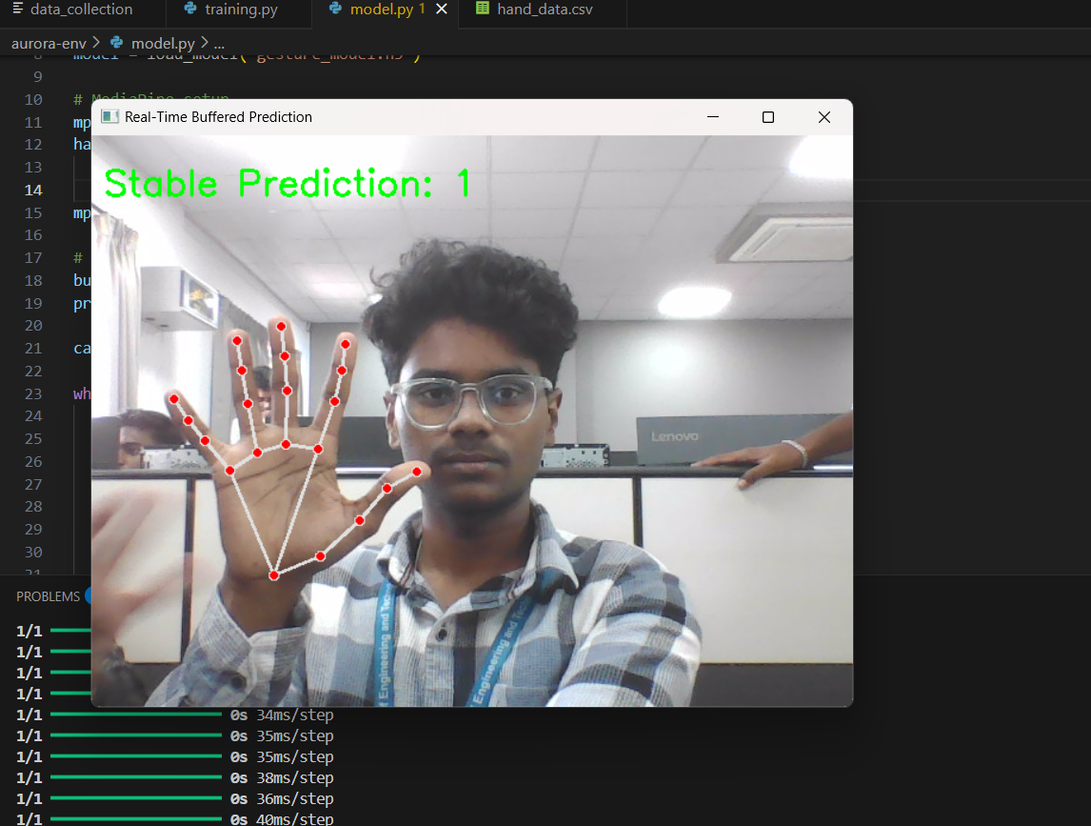

**Model prediction for ON**

## Model Training

## Load hand_data.csv

## Train neural network model to classify gestures

## Save model as gesture_model.h5

## Expected Output: Terminal output showing training progress

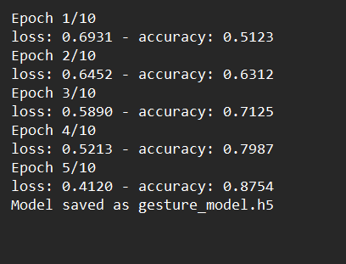

## Gesture Prediction & Communication

## Capture real-time webcam input

## Predict gesture using trained model

## Send stable prediction to ESP32 via Serial communication

## Expected Output: Console log with gesture prediction and serial message.

## ESP32 Control

## ESP32 reads serial data and toggles relay for LED control

## Expected Output: Photo/video showing LED turning ON/OFF with gesture

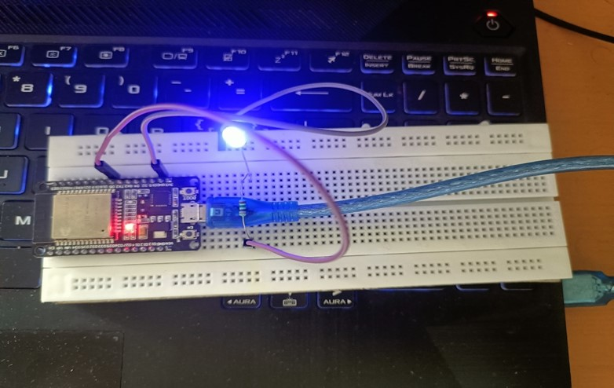

**Output for ON**